PROCTORED CERTIFICATION EXAMS
With the challenging times we are facing today, SCTE has modified the proctoring process for professional certifications. Because we may be exercising social distancing, we recognize that you may not have direct access to a SCTE proctor. There are two options candidates may use to complete a professional certification.
Option 1: PROCTORU
SCTE has maintained a relationship with ProctorU, a remote proctoring organization where candidates can complete a professional certification for a nominal cost. Please click the first link to get started. The second link is a demonstration of ProctorU.
https://www.scte.org/education/products-and-tools/product-catalog/online-remote-proctoring/
https://www.youtube.com/watch?v=0OHqItx6uz8
Option 2: SCTE PROCTORS
This option is being created due to current crisis across the nation and the world. This is a temporary solution which has been extended through September 30, 2021.
If you choose to utilize an internal resource within your organization or SCTE, follow the below steps.
- Identify an eligible proctor at https://www.scte.org/user-search/proctor/ to coordinate a date and time for the proctored exam to take place. Please schedule a time with your SCTE proctor at least 48 hours in advance of your exam.

- Once a date and time have been determined, send the following information to ldoperations@scte.org:
- Date and time of certification exam
- Email address of proctor and candidate
- Certification exam name

- SCTE will send an invite to an online meeting to both parties for the certification exam. SCTE will make the proctor the co-organizer.

- The day of the certification exam, both the proctor and candidate should make sure they have a strong internet connection. SCTE will initiate the online meeting.

- The candidate will launch the certification exam from the Purchased Certification in the Learning tab of their profile within the SCTE website. Once the candidate is ready to begin the exam, SCTE or the proctor will initiate the Record button to record the session.

- The candidate will be given presenting rights by the proctor.

- The candidate will share their entire desktop for the proctor to see. They will also activate their webcam. The candidate will pan around their surroundings for the proctor to see. If the candidate is unable to perform both actions, then the exam process will discontinue. The candidate will need to reschedule at a time when both of these are fully functional.

- The proctor should follow normal guidelines of monitoring individuals during a proctored exam. This includes examining the candidate’s photo ID ensuring it is the candidate of record. The photo ID should be placed in front of the camera so that it can be captured during the session recording. Additionally, throughout the session the proctor should ensure no exam questions are copied and allow the candidate access to reference materials while monitoring their internet usage.

- Once they launch the certification exam, the field to input the proctor’s username and pass code will appear.

- The candidate will give the proctor access to keyboard and mouse by right clicking on their name in the online tool participant list and selecting “Give Keyboard and Mouse” option. 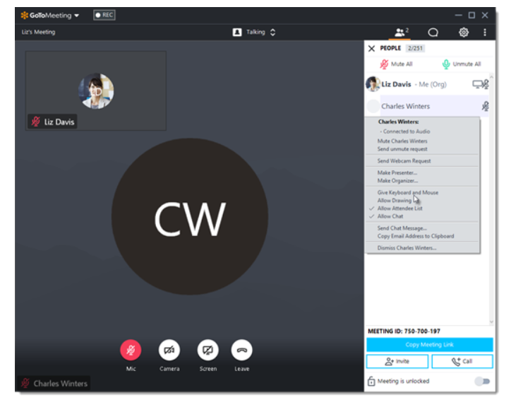

- The proctor will input their code and press enter. The certification exam will begin, and the candidate will take back control of their mouse and keyboard. They will right click on the proctor’s name via the participant list and click on “Give Keyboard and Mouse”. This will remove the check mark and then the candidate has full control of the system to proceed.

- The candidate can proceed with the exam by reviewing the Code of Ethics. Once the candidate selects OK, the exam will begin as will the exam clock.

- The proctor should monitor facial movements to see where the candidate is focused. Please take note of any issues such as internet crashing or slow movement or any questionable behaviors like talking, texting, and phone calls. Learners may use their own course notes or SCTE eBooks. In the case of a loss of connectivity, have the candidate repeat the above steps to continue the exam. If there are GoToMeeting issues, contact GoToMeeting support, Organizer issue: 888-259-8414, option 1, option 1.

- Upon completion, the candidate will select the submit button to submit the exam. Exam results are provided instantly in a pass or fail format. The candidate and proctor will close out of the online meeting.

- Upon completion, the proctor will send SCTE any notes regarding the exam to professionaldevelopment@scte.org. Please include the candidate’s full name, certification exam name, organization, and date and time of the exam.

- SCTE will extract the meeting recording and notes , then archive internally.

