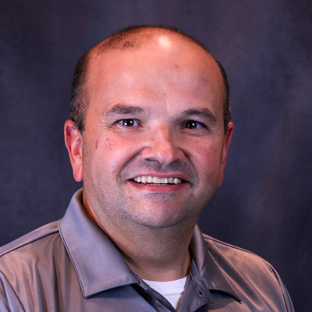

Paul Rodrigues
Director of Field Education
Paul Rodrigues has over 30 years of experience in the telecommunications industry. He joined the SCTE in 2017 to be their Director, Field Education and is responsible for the design, development, and implementation of all the field training and certification for the SCTE. He has a Bachelor of Science in Industrial Technology degree from Kean University.

Paul has experience in multiple areas, including Information Technology, Technical Operations, Management, Leadership, and Learning and Development. Over half of his career has been focused on Learning and Development. He has leveraged his experience to design and deliver training programs targeted at diverse audiences such as technical operations, sales, and senior leadership.

